**Exploratory Analyses to Screen for Within-Session Behavioral Tendencies.**

While we planned to test our hypotheses by using measures that aggregated phase data across individual sessions, it remained possible that these effects were too short-lived to be captured by the bulk session-wide analyses described above. In addition, even if drug effects are detectable using session-wide analyses, we were interested in exploring the evolution of these effects within narrower time frames. This would help further characterize the profiles of the targeted drugs, as well as inform future studies based on their pharmacokinetics. Even if we did not take any blood serum samples of the target drugs from administration, we believe that the evolution of the behavioral profiles throughout testing sessions can be used—however cautiously—as a proxy of the advent and waning of effective drug concentrations. With this in mind, we conducted within-session analyses using two techniques. One of the techniques we used was suitable for visual inspection of within-session trends and the other for exploratory hypothesis testing.

For visual inspection, we performed a sliding window analysis, which consisted of an iterative routine that selected all IRTs within a window of arbitrary duration within a behavioral testing session, starting from the beginning of such a session. For each window all the behavioral indices were computed using the IRT classification obtained through the whole-session analyses (see above). Then, the window slides to the next spot taking again the indices of interest. The latter step is repeated until the window reaches the end of the session. We used a window size of 8 min and the sliding resolution was 20 s, such that the window traverses the whole 40 min session—which spans 5 times its length—in 97 steps. The sliding resolution and window span parameters were chosen arbitrarily. This approach allowed to visually detect underlying within-session behavioral patterns possibly associated with pharmacokinetic tendencies. One advantage of using sliding windows rather than time bins to visualize measurements from discrete events is that they produce smoother trends, which helps identify underlying patterns that might otherwise be obscured by noise in fixed time bins. Figure S1 illustrates that consecutive sliding windows largely overlap, which helps in smoothing within-session tendencies. In addition, the example depicted in Figure S1 shows that two adjacent windows usually cover different subsets of IRTs.

**Figure S1**

*Example of the Distribution of Inter-Response Times Throughout a Session and Illustration of the Span of Sliding Windows*

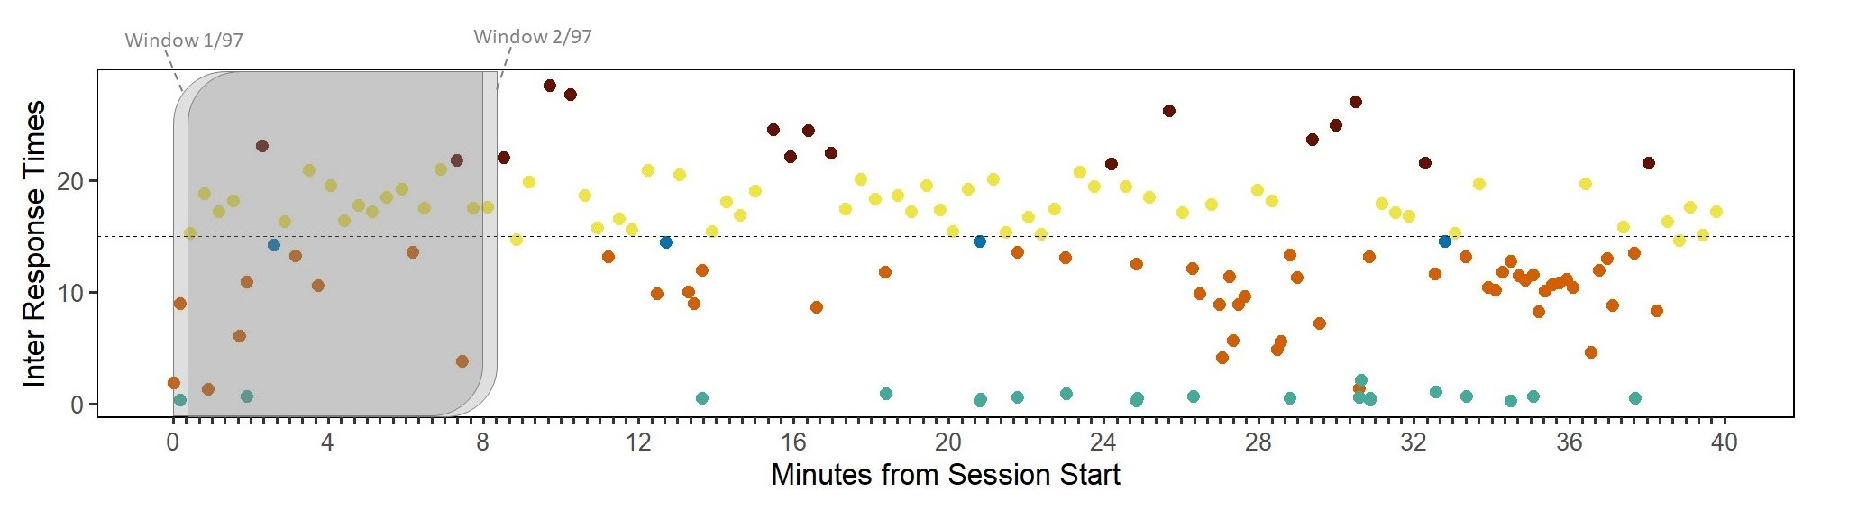

*Note*. For consistency, the data were sampled from the same subject and session as those in Figure 2 in the main article. The color of the dots represents the classification of responses. Color coding is the same as that in Figure 2 in the main article; namely, aqua for burst responses, orange for responses reflecting early inhibitory deficit, yellow for timed responses, brown for attentional lapses, and blue for other non-burst responses. The transparent gray rectangles represent the span of the first two sliding windows, while the dashed horizontal line denotes the target time. Thus, all inter-response times above this line correspond to rewarded responses.

As values obtained through sliding windows techniques inherently present a substantial degree of autocorrelation (see overlap in Figure S1), which violate assumptions of independence required by regression analysis, we took a different approach for testing if there were within-session trends associated with our drug treatments. Specifically, we regressed different outcome variables using the time from the start of the session as a continuous predictor. Since we intended this analysis to harmonize with the metrics obtained session-wide, several classes of responses were dissected from a session to constitute regressions to interrogate the different behavioral features captured by each index (except for the efficiency index).

To capture the trend of obtained rewards throughout the session we simply regressed the inter-reward intervals with the time at which each reward occurred. To assess the trend of burst responding across the session, we included the raw values of IRTs of responses classified as bursts and the values of IRTs classified as timed set at the mean of all timed IRTs in the session. The rationale behind fixing timed IRTs was to detect the relative occurrence of bursts without any influence of variability in timed IRTs. In a similar vein, to assess the trend of early inhibitory deficit, we included the raw values of non-burst IRTs to the left of timed responses and the mean-fixed values of timed IRTs. To assess the trend of the timing peak we simply regressed the raw IRTs of timed responses against time from the start of the session. To capture the trend of timing spread, we obtained a local coefficient of variation from each pair of timed IRTs and regressed it with session time. This required obtaining the square root of the squared difference between each timed IRT and the preceding timed IRT and then dividing this value by the mean; formally, √((timed-IRTn – timed-IRTn – 1)2)/mean(timed-IRTs). Finally, to assess the trend of attentional lapses within the sessions, we included the raw values of IRTs classified as attentional lapses and the mean-fixed values of timed IRTs. Therefore, we had a total of six datasets for regressions, representing obtained rewards, burst responding, early inhibitory deficit, timing peak, timing spread, and attentional lapses. For a summary of how each data-set was constituted, refer to Table S3.

**Table S3**

*Data Arrays Used in Within-Session Regressions*

|  |  |  |  |  |  |
| --- | --- | --- | --- | --- | --- |
| **Origin of data →**  **Feature of performance intended to be captured ↓** | *Burst responses* | *Early inhibitory deficit and other non-burst responses* | *Unrewarded timed responses* | *Rewarded timed responses* | *Attentional lapse responses* |
| *Obtained rewards* |  |  |  | Inter-reward intervals | |
| *Burst responding* | Raw IRTs |  | Mean-fixed IRTs | |  |
| *Early inhibitory deficit* |  | Raw IRTs | Mean-fixed IRTs | |  |
| *Timing peak* |  |  | Raw IRTs | |  |
| *Timing spread* |  |  | Local coefficient of variance | |  |
| *Attentional lapses* |  |  | Mean-fixed IRTs | | Raw IRTs |

All of the above-described data arrays were regressed against time from the start of the session, hereafter referred to as timestamps. We performed this analysis just for contrasts involving adjacent phases of our experiment, namely, Baseline vs Drug phase (denoting acute effects) and Drug vs Washout phase (denoting recovery from the effects of the drugs upon discontinuation) contrasts. Hence, we report the result of a total of 12 regressions. In addition, we tested two models to evaluate our data. One of these models accounted only for monotonic within-session trends and the other incorporated the possibility to detect biphasic trends. Both models were compared via AIC and we only report the result of the model with the best goodness of fit. For detecting monotonic trends attributable to drug treatment, we regressed our outcome variables against raw timestamps in interaction with the factors accounted by our study’s design (i.e., phase and group); in mixed-effects modeling notation this would be expressed as outcome ~ phase * group * timestamp + (1 | subject). For detecting biphasic trends, we regressed outcome variables against triple interactions of both raw timestamps and squared timestamps; in mixed-effects modeling notation, this can be expressed as outcome ~ (phase * group * timestamp) + (phase * group * timestamp^2) + (1 | subject). For each drug group (Methylphenidate and Modafinil), we report either the coefficients of triple interactions associated with raw timestamps to account for within-session monotonic trends (linear model) or those associated with squared timestamps to account for biphasic trends (quadratic model). All p-values from these regressions were compared against Bonferroni–Holm and Benjamini–Hochberg corrected α values. For the full list of significance outputs, refer to the Supplementary Materials folder.

**Results**

To begin with, we show that our sliding window analysis provides fine-grained aspects of performance in our DRL task that were eluded by session-wide analyses. For example, session-wide analyses in Figure 3 (see main article) show that the peak of timed responses is robustly linearly correlated with obtained rewards—both cross-sectionally and longitudinally—whereas timing spread correlated with this global index to a lesser extent longitudinally and not at all cross-sectionally. In contrast, Figure S2 shows a complex relationship between these three variables using data from sliding windows. In agreement with Freestone et al. (2015), the relationship between the peak of timed responses and reward rate (i.e., obtained rewards per unit of time) is modulated by the spread of timed responses. Generally, as timing spread increases, reward rate decreases. Nonetheless, the relationship between these variables is more intricate than it appears. When the values of peak and spread are too low, reward rate falls strikingly, it then increases steeply shortly after the timed peak exceeds the temporal criterion imposed by the DRL task (in this case, 15 s), and falls again sharply as the values of timed peak stray from the temporal criterion. A similar biphasic trend is observed with higher values of timing spread except that in such conditions exceptionally low values of timing peak are not conspicuously suboptimal, and obtained rewards reach the highest point with higher timed peak values. Altogether, this instantiates the content validity of our data segmentation technique, as it reveals a pattern that satisfies predictions about response profiles specific of the cognitive ability under investigation (see Völter et al., 2018). Such a result is uniquely achieved through the sliding windows analysis, likely because of two factors: the increase in the number of data-points analyzed and the release of the values from the range restriction imposed by including larger samples of IRTs.

**Figure S2**

*Modulation of the Relationship Between the Peak of Timed IRTs and Obtained Rewards by Timing Spread*

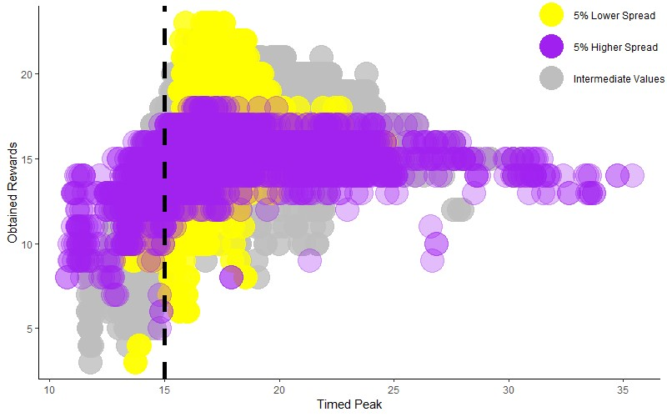

*Note*: Each point represents the values obtained from the variables of interest for all windows throughout the experiment.

For visualization purposes, we obtained standardized beta coefficients by running a mixed model with factors for phase, group, and window but treating the window element as a categorical, rather than a numeric one (see Supplementary Materials folder). Categorical window elements remove linear constraints from the model, enabling the model to detect complex within-session performance patterns. Therefore, coefficients represent deviations from expected values, where the reference factors are: the target phase (i.e., the phase to the left of the dash in Baseline–Drug and Drug–Washout contrasts), Vehicle group, and Window number 1. Standardized beta coefficients associated with these regressions along with their standard errors are depicted in Figure S3. As shown, some indices fluctuate around zero, reflecting no substantial departure from the expected reference. Deviations from zero indicate within-session epochs where performance attributable to drug treatment is above or below expected trends. Patterns in the Drug–Washout contrast (left column) showing something akin to an inverse mirror shape of the Baseline–Drug contrast (right column) would be especially suggestive of a drug-specific effect. The most notable effect depicted in Figure S3 is that associated with an increase in rewards obtained by subjects in the Methylphenidate group shortly after the beginning of the session, which then partially diminishes toward the end.

**Figure S3**

*Within-Session Performance Patterns Upon Pharmacological Treatment and its Discontinuation*

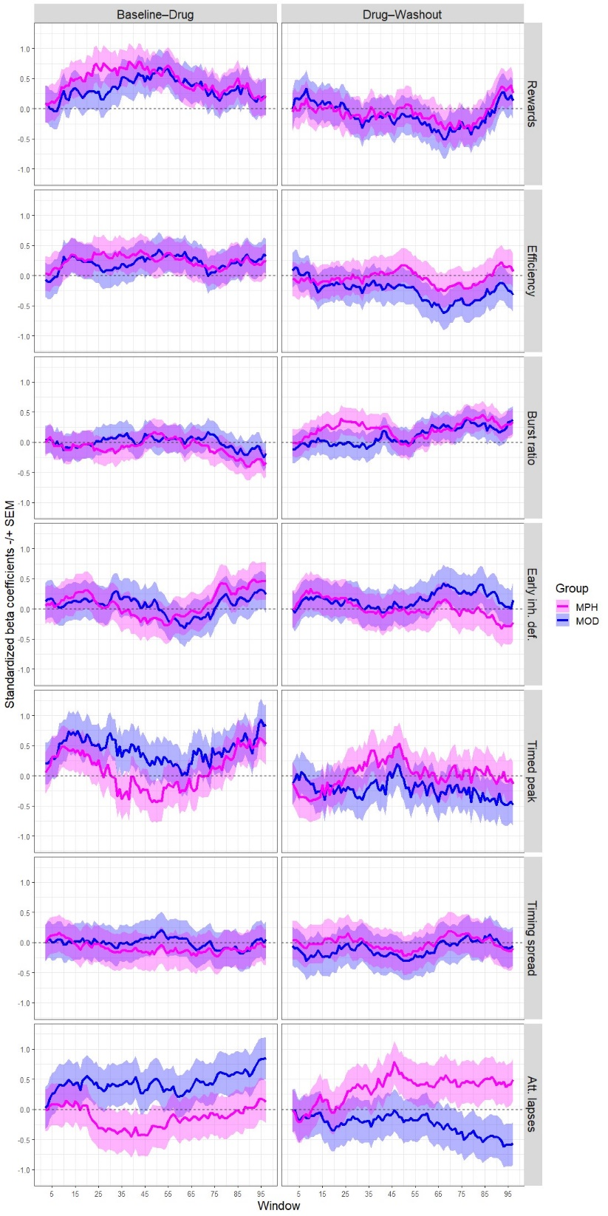

*Note*: The beta coefficients shown in this figure were obtained by running a phase × group × window mixed model but processing the window element as a categorical—rather than a numeric—variable. This allowed to release the model from linear constraints to depict complex within-session performance patterns. Therefore, coefficients represent deviation from expected values taking as reference the target phase (i.e., the phase to the left of the dash in Baseline–Drug and Drug–Washout contrasts), Vehicle group, and Window number 1.

A more objective exploration of within-session effects was carried out using a regression analysis involving several outcome variables (see Table S3) against the time elapsed since the start of the session, the results of which are shown in Table S4. As can be seen, most contrasts were better described by the quadratic model; in that case, we report the standardized β coefficients of the triple interaction between phase, group, and squared timestamp, which capture the curvature of the within session trend. In some instances, the linear model showed a better goodness of fit, in which case we report standardized β coefficients of the triple interaction between phase, group, and raw timestamp to capture the slope of the within session trend. Credible within-session acute drug effects would imply effects with opposite signs in Baseline–Drug and Drug–Washout contrasts for any given drug and behavioral index. This is because discontinuing the administration of a drug with reversible effects should promote an inverse change pattern compared to that observed when starting its administration (Venitz, 1995). Table 3 shows that this is the case for many contrasts. Nevertheless, very few effects were substantial, let alone significant. For both methylphenidate and modafinil, the curvature was positive, moderately large, and significant (according to the most lenient of our criteria) for obtained rewards in the Baseline–Drug contrast. A positive curvature means that the trend is U-shaped, which confirms what was observed in the sliding windows analysis (see Figure S3). Note that in the sliding windows analysis obtained rewards were coded by their numerical count, leading to an inverted-U shaped trend, while in the regression analysis this variable was coded as inter-reward intervals; hence, the result was opposite yet commensurate. This suggests that, compared to the change in the within-session trend exhibited by the subjects of the Vehicle group from the Baseline to the Drug phase, drug-treated subjects obtained more rewards somewhere in-between the beginning and the end of the session.

**Table S4**

*Result of Regressions Assessing Within-Session Trends*

|  |  |  |  |  |  |  |
| --- | --- | --- | --- | --- | --- | --- |
| Behavioral Attribute | Contrast | Element of interest | Standardized *β* coefficient (95% CI) | | *p*-value and significance | |
| Methylphenidate | Modafinil | Methylphenidate | Modafinil |
| Rewards | BL–Dr | curvature | .38 (.13–.63) | .38 (.13–.63) | ***.0026&*** | ***.0031&*** |
| Dr–Wo | curvature | -.26 (-.50–-.01) | -.28 (-.54–-.03) | ***.0416*** | ***.0270*** |
| Bursts | BL–Dr | curvature | -.06 (-.26–.14) | .30 (-.22–.15) | .5407 | .7320 |
| Dr–Wo | curvature | .12 (-.08–.33) | .04 (-.15–.23) | .2490 | .6695 |
| Early Inh. Deficit | BL–Dr | curvature | -.17 (-.37–.03) | -.08 (-.28–.11) | .0887 | .4068 |
| Dr–Wo | curvature | .08 (-.12–.28) | .09 (-.1–.29) | .4573 | .3558 |
| Timed Peak | BL–Dr | curvature | .01 (-.22–.24) | -.18 (-.41–.05) | .9084 | .1303 |
| Dr–Wo | curvature | .02 (-.22–.25) | .10 (-.13–.33) | .8915 | .4092 |
| Timing Spread | BL–Dr | slope | .23 (-.02–.48) | -.06 (-.31–.19) | .0689 | .6419 |
| Dr–Wo | slope | -.01 (-.07–.05) | .05 (-.01–.11) | .7620 | .1100 |
| Att.  Lapses | BL–Dr | slope | .01 (-.04–.06) | .07 (.02–.13) | .7601 | ***.0063*** |
| Dr–Wo | curvature | -.04 (-.25–.17) | -.06 (-.27–.15) | .7141 | .5710 |

*Note*: The elements of interest, of which we report standardized β coefficients, were determined by whether the linear (slope) or the quadratic (curvature) model showed better goodness of fit for each particular contrast. Abbreviations: BL = baseline, Dr = drug, Wo = washout. p-values lower than .05 were bolded and italicized, but only those featuring superscripts are considered statistically significant; we used a “#” superscript to tag contrasts that remained statistically significant after the Bonferroni–Holm correction for multiple comparisons, and a “&” for significant contrasts after Benjamini–Hochberg correction. The full list of corrected α values and the output of the Chi squared tests to evaluate the goodness of fit of models is included in the Supplementary Materials.

In agreement with the result described above, for both methylphenidate and modafinil groups, the curvature was negative and medium-sized for obtained rewards in the Drug–Washout contrast. This also converges with the seemingly negative-mirroring of the Drug–Washout trend with respect to that associated with the Baseline–Drug contrast (see Figure S3). However, although the p-values for this contrast were below the conventional significance threshold (i.e., .05), they did not survive either of our multiple comparison correction methods. Another result worthy of commentary is the within-session trend of subjects administered with modafinil regarding attentional lapses. In this case, the best-fitting model was the linear one. The standardized coefficient for the slope was small and the p-value was below the standard α level. While this result does not attain significance following the application of our correction methods, it aligns with the visual analyses (refer to Figure S3), where a discernible within-session trend of increasing attentional lapses is evident among subjects administered with modafinil. Whether due to chance or actually due to treatment, this result would indicate that subjects administered with modafinil tended to disengage from the task as the session progressed.

From this analysis, we conclude that there is only weak evidence that methylphenidate had a short-lived cognitive-enhancement effect that might have gone undetected by whole-session aggregate analyses. This has only been observed for obtained rewards in the Baseline–Drug contrast, passing only one of the most lenient corrections for multiple comparisons for statistical significance. While the Drug–Washout contrast for obtained rewards in the Methylphenidate group yielded the expected opposite effect, its p-value did not survive any of our corrections for multiple comparisons. The modafinil group showed a similar pattern of results regarding obtained rewards, indicating that subjects treated with modafinil earned more rewards than expected at some point between the beginning and the end of the session. However, these results cannot be considered conclusive because they did not reach our most stringent significance threshold. Additionally, after drug discontinuation, subjects previously treated with modafinil showed a slight improvement in task engagement, but this tendency was neither associated with a concomitant improvement in obtained rewards nor passed our corrections for multiple comparisons. The absence of significant within-session effects in the efficiency and early inhibitory deficit indices, which showed robust session-wide effects upon administration for subjects treated with modafinil, suggests that the effects induced by this drug were stable throughout the 40-minute sessions of the behavioral task.

**References**

Freestone, D. M., Balci, F., Simen, P., & Church, R. M. (2015). Optimal response rates in humans and rats. *Journal of Experimental Psychology: Animal Learning and Cognition, 41*(1), 39. <https://doi.org/10.1037/xan0000049>

Völter, C. J., Tinklenberg, B., Call, J., & Seed, A. M. (2018). Comparative psychometrics: establishing what differs is central to understanding what evolves. *Philosophical Transactions of the Royal Society B: Biological Sciences, 373*(1756), 20170283. <https://doi.org/10.1098/rstb.2017.0283>